Software Requirements Specification Template

Smart Inventory Web

Software Requirements Specification

Windows 7
09/30/2018

Satya Phani Shyam Appasani
Pavithra Devdas
Venkata Ajit Kumar Dokka
Sri Ram Teja Komerisetti
Prashanth Kumar Thallada
Vyshnavi Srilaxmi Thannir

Submitted in partial fulfilment
Of the requirements of
CSIS 44-691 Graduate Directed Project 1

Document Approval

The following Software Requirements Specification has been accepted and approved by the following:
Signature | Printed Name | Title | Date
VT | Vyshnavi Srilaxmi Thannir | Project Manager | 09/21/2018

Table of Contents

Table of Contents Page Number

- Introduction
  - Purpose:
The main Purpose of this is to create a website for a vendor and distributers where the vendors can bid for the required products so that a vendor can select the product at low cost as possible which will benefit his job.
  - Scope:
The scope of the project is that this website helps the Vendor to select the dealer of the choice and the price he wanted and number of products that he requires.

  - References
  - Overview
  - Functional Requirements(Revised)
Functional Requirements of the Admin(Vendor):
- Login credentials for the vendor to login and access his account.
- Password recovery in case of forgotten password
- Request to delete the account of the physical store owner.
- Provision to change Password and password must be minimum of 8 characters and include special characters.
- Should have access in case of Forget Password and create a new password.
- Visibility of distributers request where the vendor can see the costs of the different products and select the matched one.
- Able to accept and delete the requests of the distributors in the file.
- Should have platform for payment for the distributors.
- Track the product shipping details
- Able to view user contact details
- Get Bid information where he can view for which amount the product has be sold and to which customer
- Able to send the shipment details if the user is selected.
- Able to track the product shipment

User Requirements(Revised):
- A new user should register with name, email address, password and re-enter of password.
Name | Email Address | Password | Re-Enter Password
- If the user already has an account, the use will login with email address and password.
Email Address | Password
- Once the user as logged in, the user can request the no of items from the vendor and it will be displayed.
- The user will have a request button or email to get the shipping label and request for payments from the vendor.
- All the distributors will have the common plat form for viewing the requests based on the product.
- Once the vendor looks at the request, vendor sends an email to the user a downloaded file with shipment details.
- The user will have access to the downloaded shipment label.
- User having the ability to select how many products he can deliver.
- The user will add the shipping address and have a button to upload the shipping receipt which will be visible to the vendor.
- The user details will be displayed both to user and vendor when they click on the details.
Name | Email Address | Items Recorded | Shipped Address to | Payment received

ER-Diagram Smart-Inventory Web (Revised) :
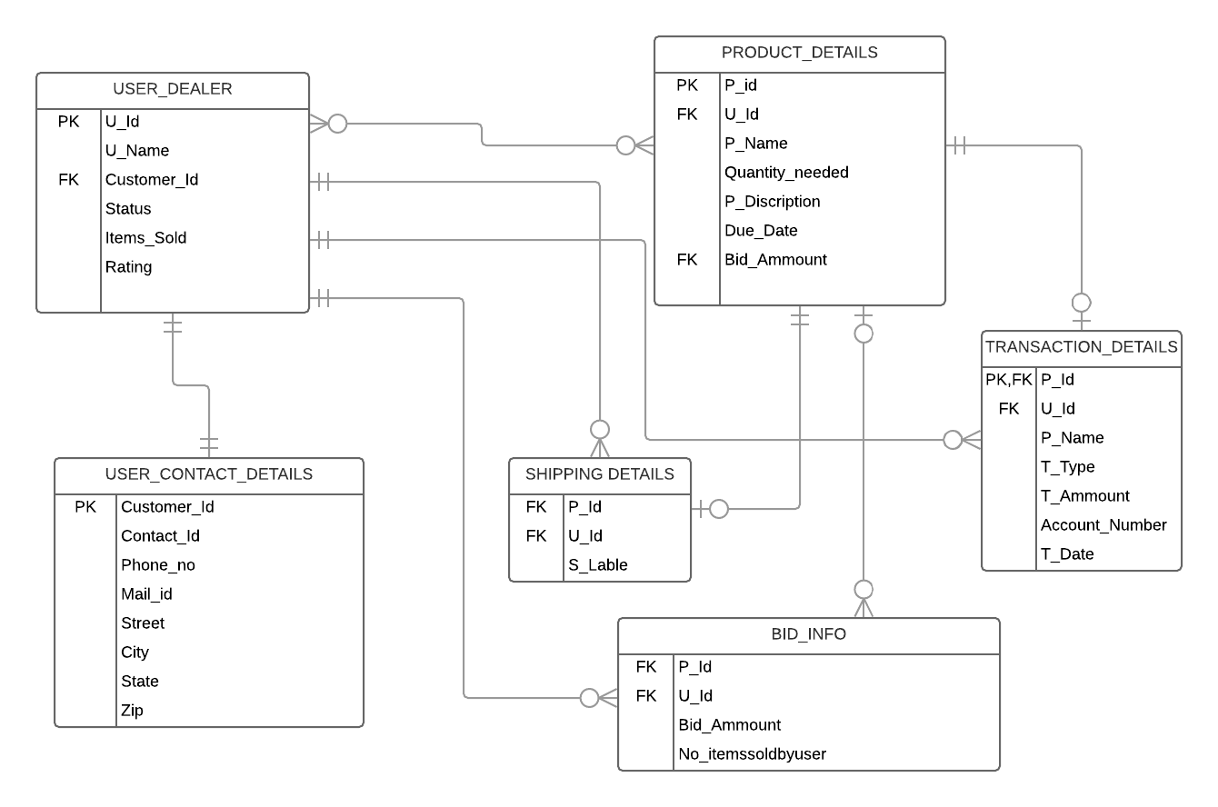

Mock up(proto-type) User:
User login page:

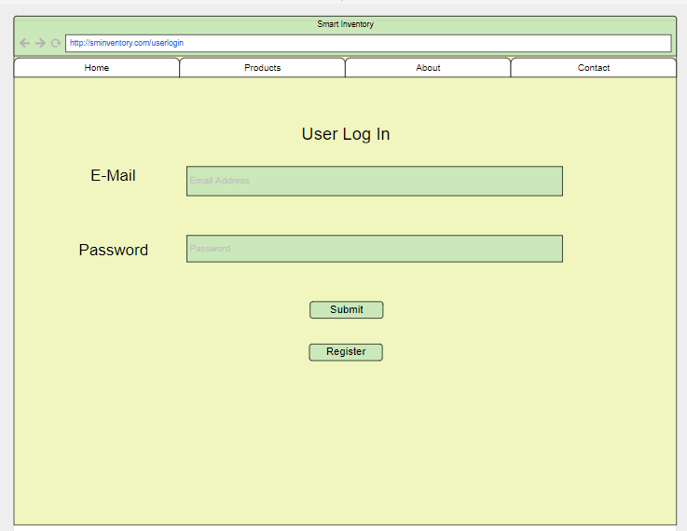

If new user he need to Register:
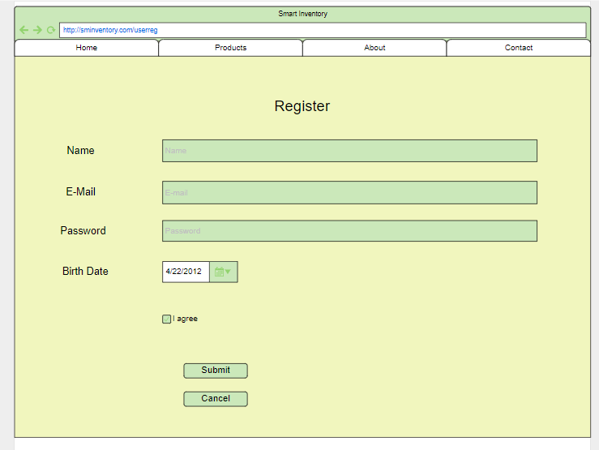

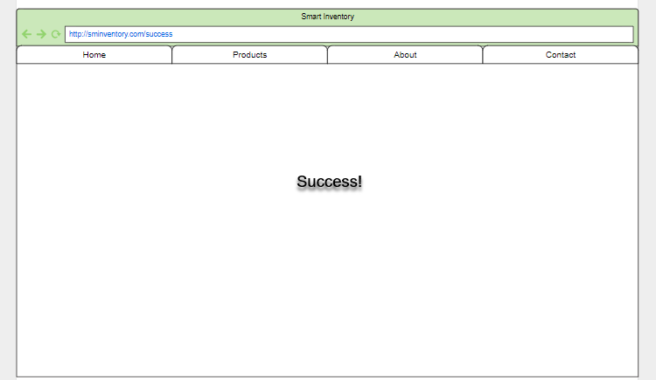

Products:
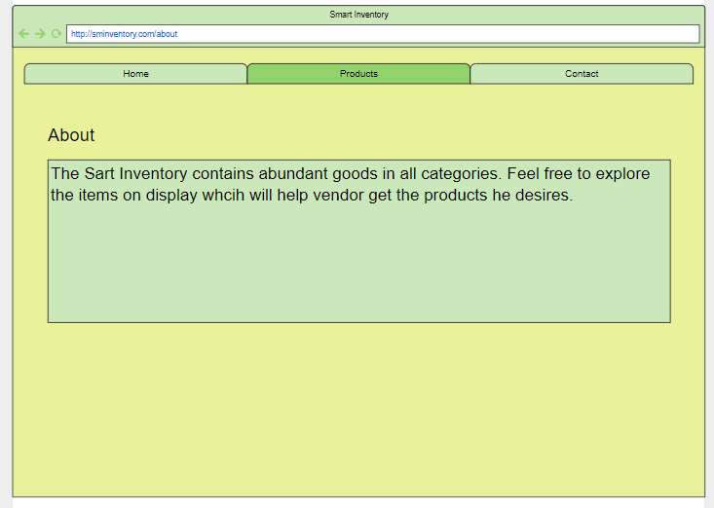

Details 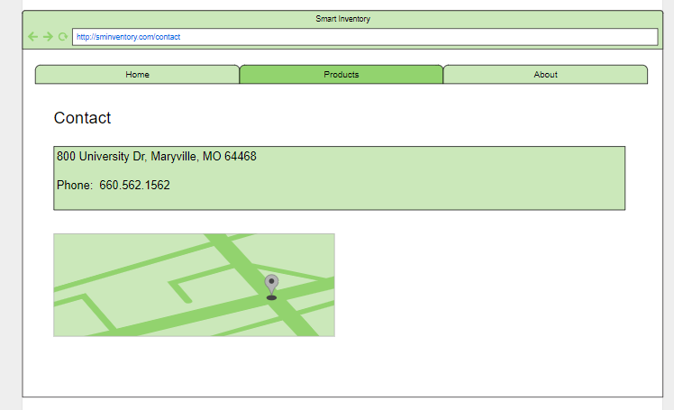

Items to select and its description
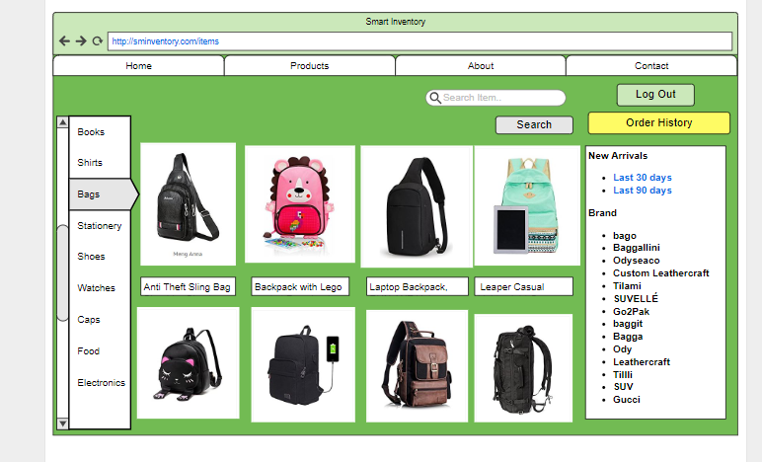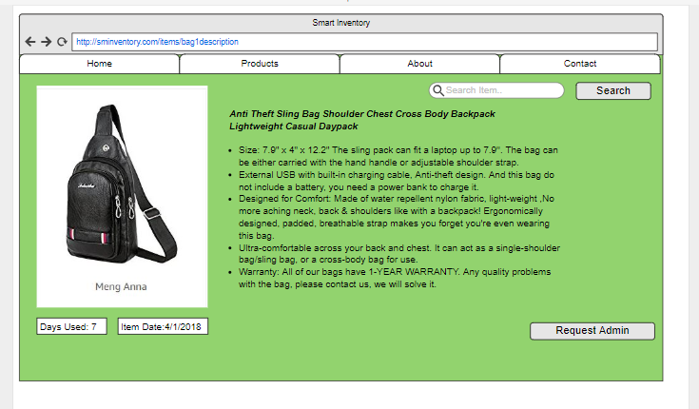

If Vendor(Admin) accepts the user request:
It admins accept the user
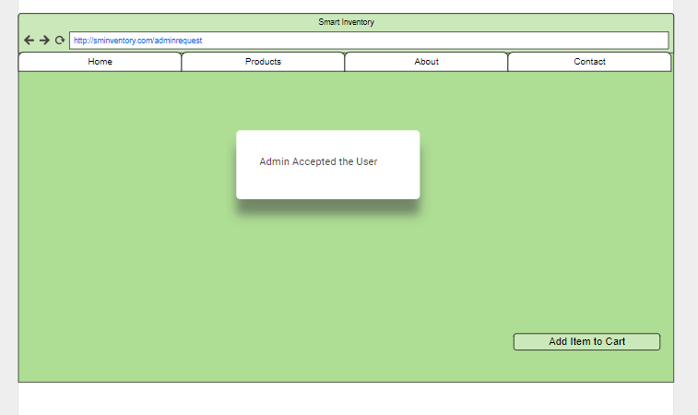
Then you get the purchase conformation and get shipping details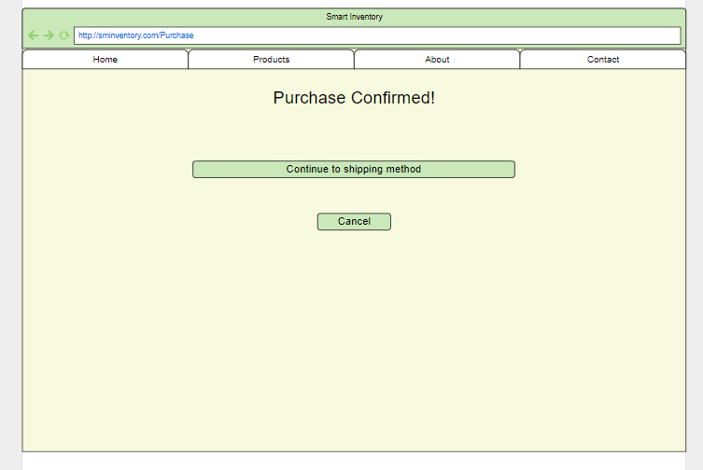

Then get information of admin accept or reject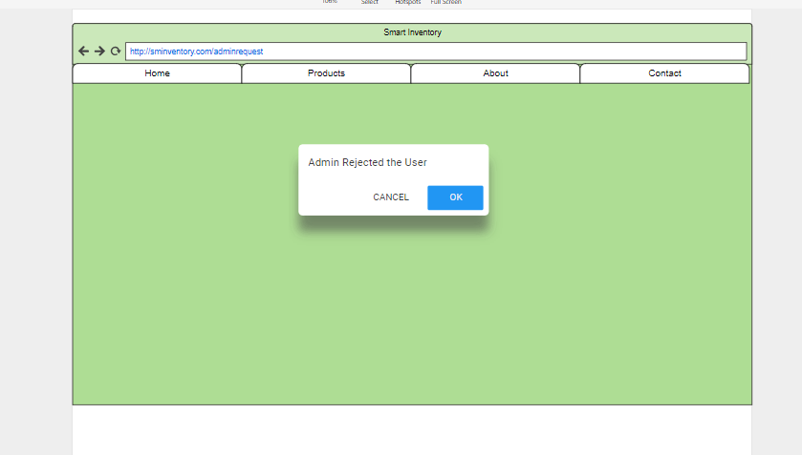

Shipment table to the user and payment confirmation
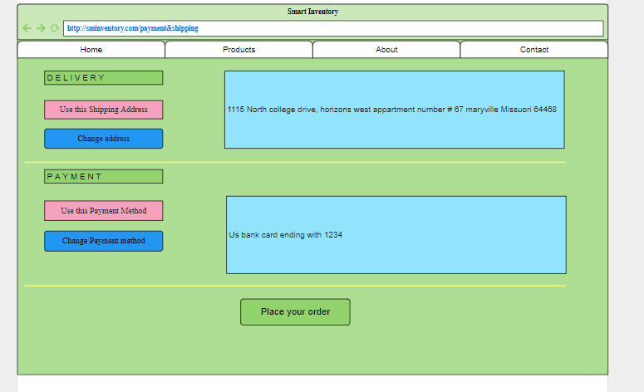
Vendor(Admin) login:
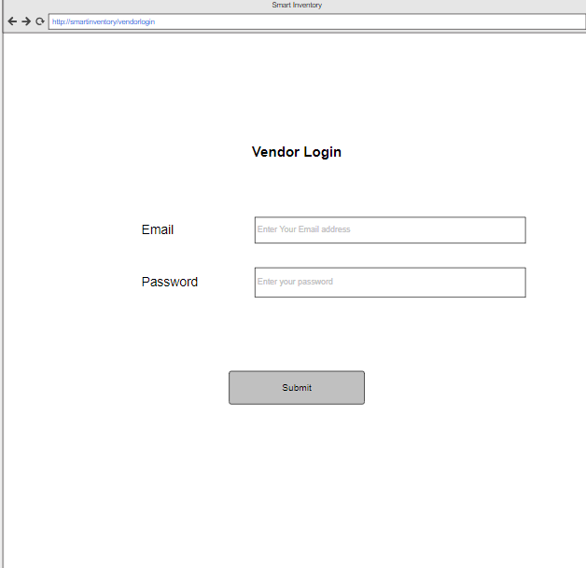

Vendor will select which item he required and quantity of the items and by which date he require them and post them so that the user can see.
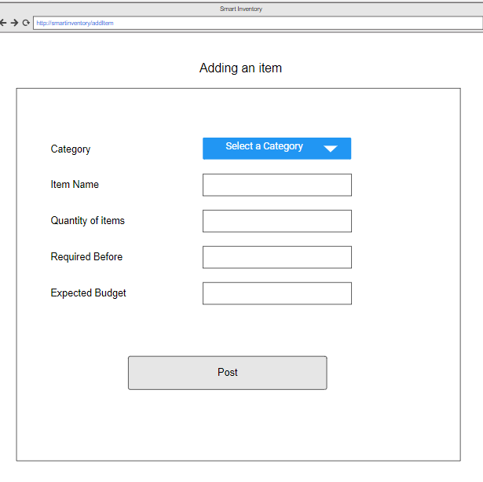

He will have the Visibility of users who bid for particular item where he can accept or deny the particular user.
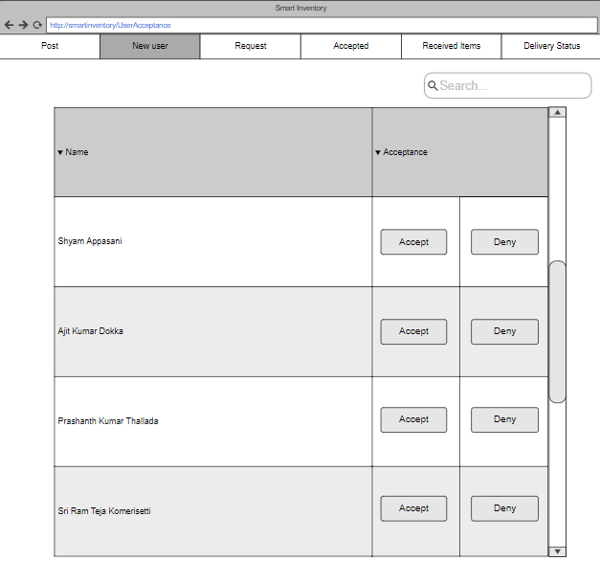

He will have an option to delete the item once he complete his requirement
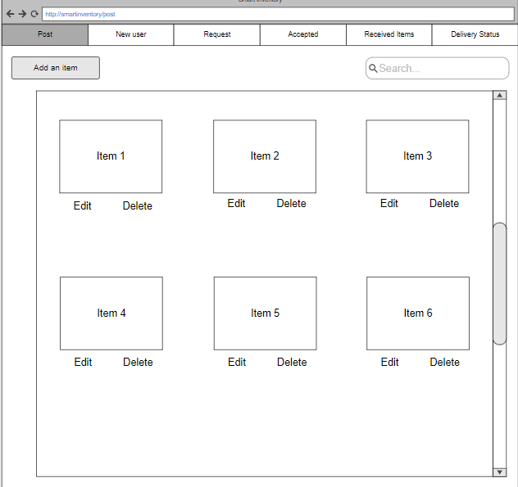

He can See name of product and how many a user will give them and to accept them.
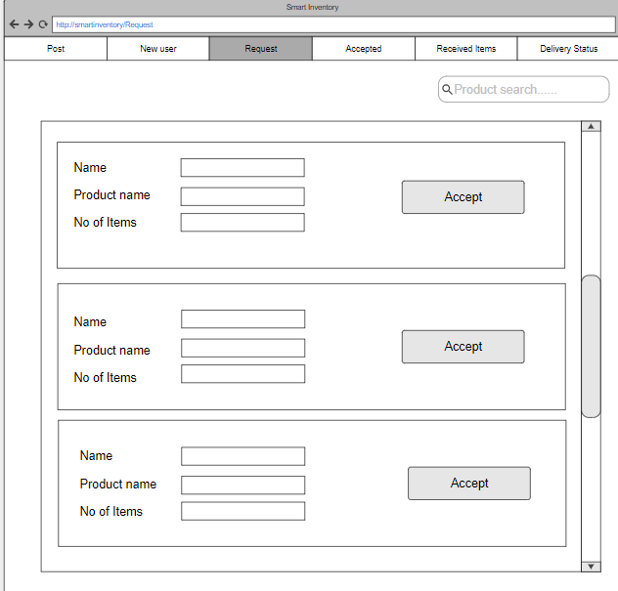

Once the user is selected he will have access to send shipment lable to the use:
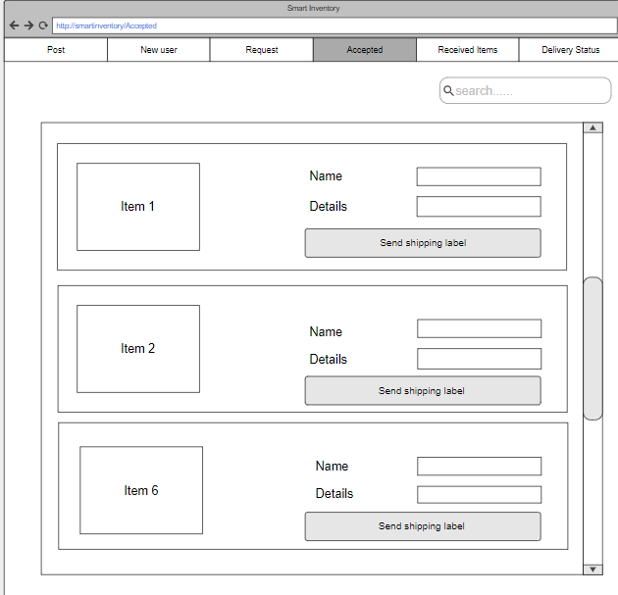

Once the items are finalized and delivered to the vendor he can make a payment :
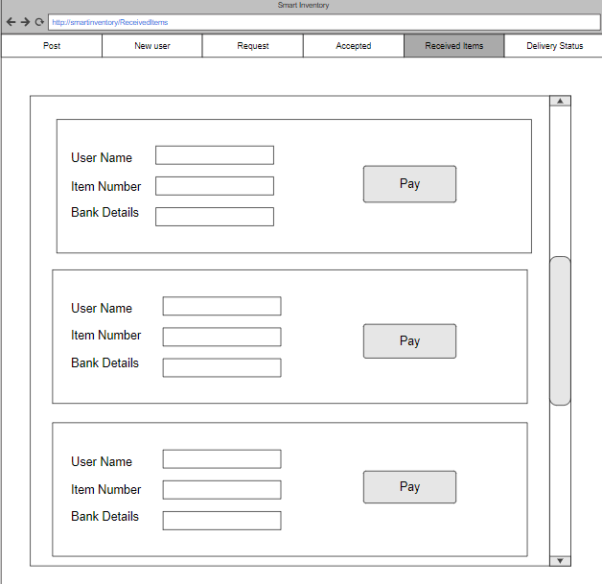

Once vendor selects payment he has to enter the account details:
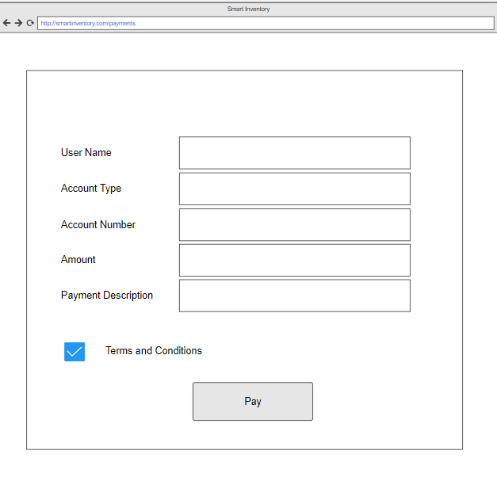

Vendor can know the status of the products that are delivered:
